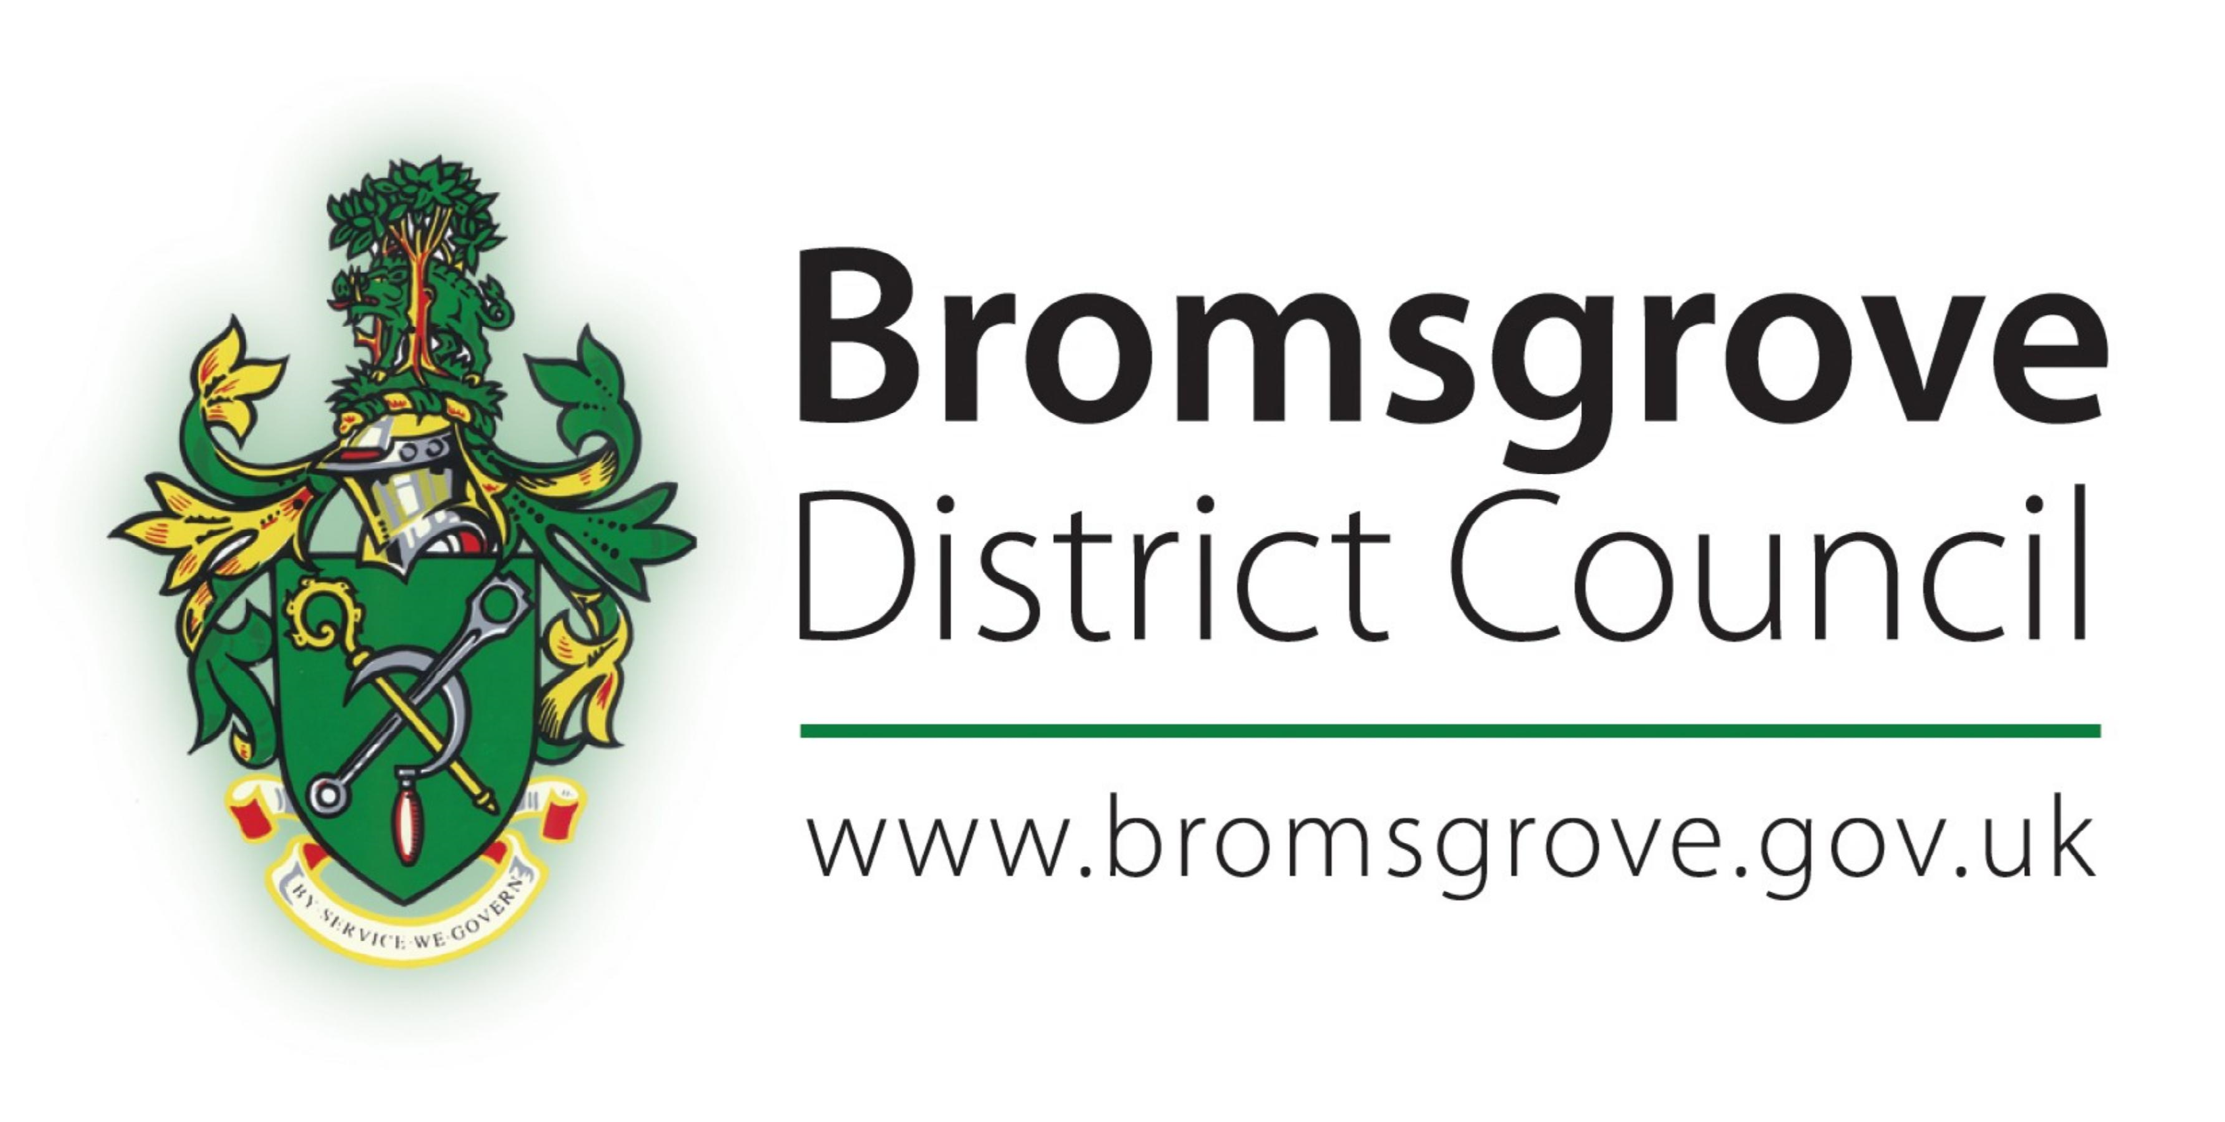 |  | 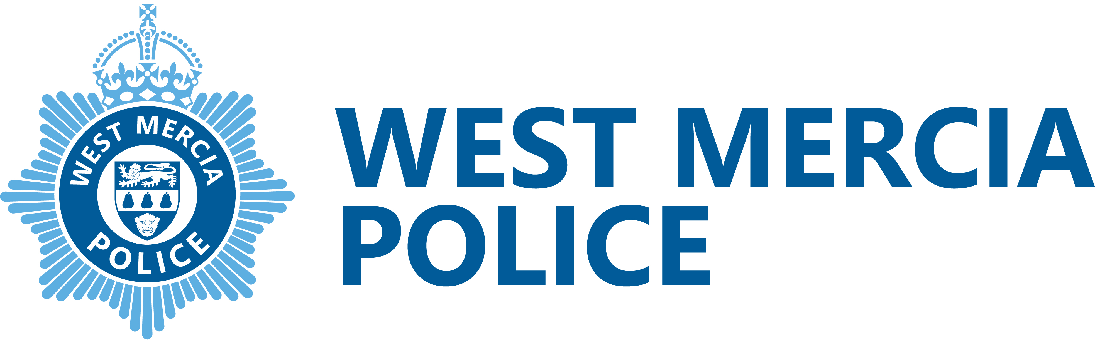

TO ALL PARENTS/GUARDIANS

Dear Parent/Guardian November 2023
PARKING AT SCHOOLS WITHIN BROMSGROVE DISTRICT AND REDDITCH BOROUGH

This is a joint letter sent by Bromsgrove District Council, Redditch Borough Council and West Mercia Police, reminding all parents/guardians, when dropping off and picking up their children at school, to comply with traffic road markings such as double yellow lines, zig-zags, etc., and to avoid obstructing vehicle access points which serve private properties.

While many parents and guardians are adhering to the rules of the road and parking safely, there are a small minority who unfortunately do not. This is putting children at unnecessary risk of harm on their way to and from school, and causing access issues to residents living in close proximity to our schools.

There are a number of important points that we would like to bring to your attention:

- Where at all possible, parents/guardians are asked to walk their children to and from school. This not only helps with traffic congestion but promotes active travel options and health and fitness. However, we fully appreciate that many parents need to transport their children to school by car for a number of reasons. If you do need to drive to school, please ‘park and stride’, leave your car 5-10 minutes’ walk away from the school and walk the rest of the journey. This will help to ease congestion close to the school where children and parents will be crossing;

- If you are a driver, you have a responsibility to ‘stop and think’ about whether you are parking in a safe and considerate manner. If you do not, you could be endangering a child’s life. Co-operation and consideration for others is the key. It is not about competition for the best parking space, it’s about the safety of your children and everyone else in the area;

- Traffic Regulation Orders (TROs) are implemented in areas by the Highway Authority after careful consideration and consultation with many relevant partner agencies. In general, their implementation is not only to assist with the free flow of traffic, but primarily to ensure that highway safety can be achieved, for all road users. Please remember, children’s safety should always be in the drivers’ mind when approaching the school. Enforcement takes place to ensure these rules are adhered to, and ultimately to improve the safety of the roads for everyone who uses them;

- Did you know? One in five cars on the road during the morning rush hour is transporting children to school. Please ensure you allow sufficient time to travel. If you must use a vehicle, ‘just this once’ or ‘we are running late today’, are NOT valid excuses for ignoring the rules of the road and putting other road users in danger;

- Please ensure your vehicle is not blocking any access into a private property when you park. This can be classified as an obstruction of the highway. Many of us have experienced being blocked in in some form or another and understand how frustrating this can be.

Civil Enforcement Officers and Police Officers will continue to attend schools during drop-off and pick-up times where possible, and will enforce parking and driving offences as necessary, to ensure that the safety of children during these times remains paramount. Please therefore adhere to any restrictions in place around your school to avoid the possibility of any Penalty Charge Notices being issued.

Please also take the time to contact your own particular school, to see if they have considered the introduction of ‘walking buses’ or can provide advice on other available alternatives to driving, which are applicable to their particular site.

Your assistance in these matters will be greatly appreciated.

Yours faithfully | Yours faithfully
Pete Liddington  Engineering Team Leader  Engineering and Design Services for both Bromsgrove DC and Redditch BC | Paul Waterhouse  Traffic Management Advisor  West Mercia Police

